.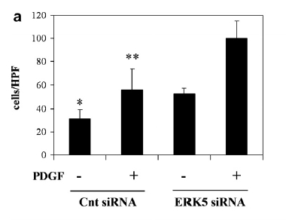

The barogram represents the mean ± SE of three
independent experiments. *P < 0.05 vs. unstimulated cells treated with
ERK5 siRNA; **P < 0.05 vs. cells treated with ERK5 siRNA and exposed to PDGF

